Assignment 6
Boyan Hristov, Gerrit Hinderland, Jonas Piotrowski – Gruppe 2

original picture:

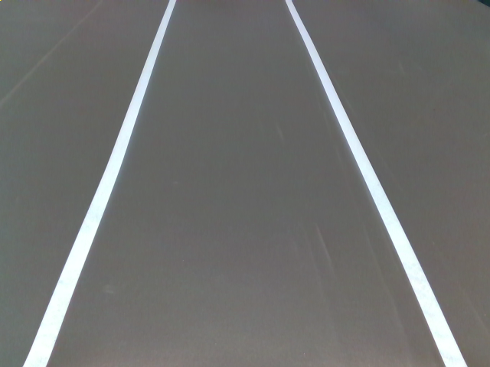

2:
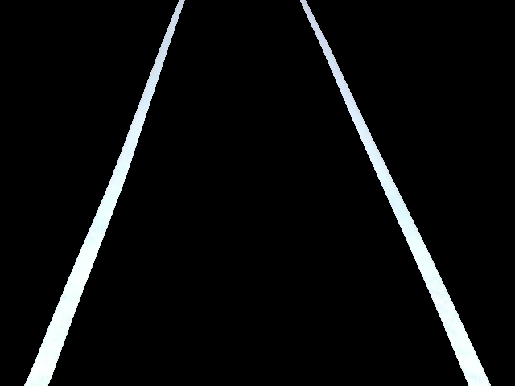
RGB
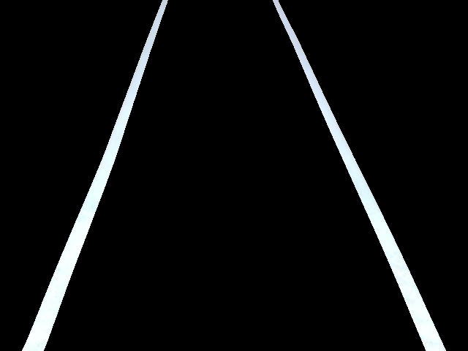
HSV

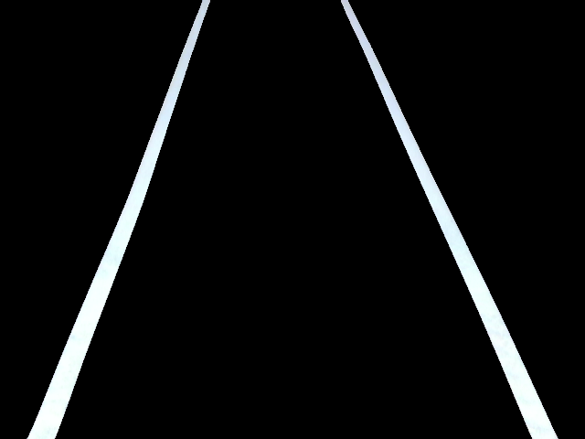
YUV

The worst color space of RGB, HSV and YUV to segmentate an image is YUV.
YUV makes it quite hard to set to optimal margins, because they need to be in the middle of the U and V spectrum. If the color is then a little green-ish white, it may be harder to recognize aswell.

To decide between HSV and RGB is easy. To get plain white you need to set the margins of R,G and B to the maximum. In HSV you may set H to any color and minimize the Saturation and maximize the Value (Brightness). You then get all color variances of white with RGB and HSV.

But with HSV it is easier to find the right settings to get your desired colors. Just adjust saturation and value to get stronger colors. OR to get only one color for example you can find it in the H(Hue) and set a margin around it there. Then you’ll get for example only a green-ish white.
RGB makes this task much harder. (e.g. how to get a pink-ish white?)

HSV is the best. It recognizes colors easier, also with high brightness and saturation.

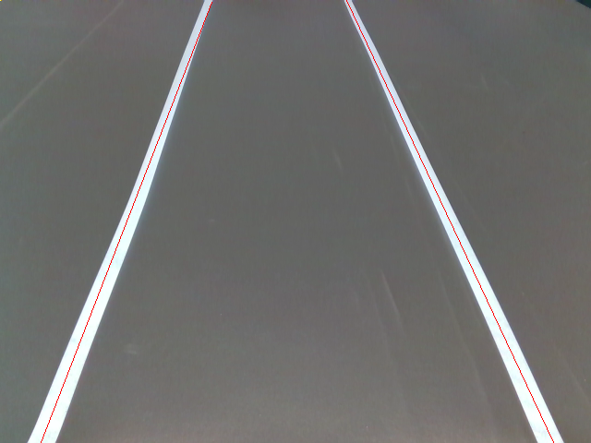
3.
detected lines

functions for lines:

Line 1: 2.1543821516x + (-809.252318075); Line2: -2.58217880486x + (594.528828494)

